Görkem Enes Bektaş
bektasgorkemenes@gmail.coım
Politechnika Czestochowa

Berke Can Kaya
bluten07@gmail.com
Politechnika Czestochowa

Signal analysis and Data processing

Laboratory Class - Experiment 4

-Cross-Correlation-
Introduction
Cross-correlation is a mathematical technique used to measure the similarity between two signals. It involves shifting one signal over time to determine how much it aligns with another signal. This method is commonly applied in fields such as time series analysis, signal processing, and image processing. Cross-correlation is calculated by summing the products of the overlapping parts of the two signals, and a high value indicates strong similarity between them. This technique is widely used to detect delays, identify relationships between signals, analyze anomalies in data, and compare the responses of different systems.

Compulsory Tasks:
- We combine a cine signal with a frequency of 12 and an amplitude of 6 with a noise with a standard deviation of 2 and give another signal from a channel with the same values. As a result, we have 2 composite signals with the same values. A stationarity test is performed for the cross-correlation function formed by these signals. Since the standard deviation values we have chosen are low, the signal is not clear in the first way, but as the signal length is increased, the signal becomes more clear.
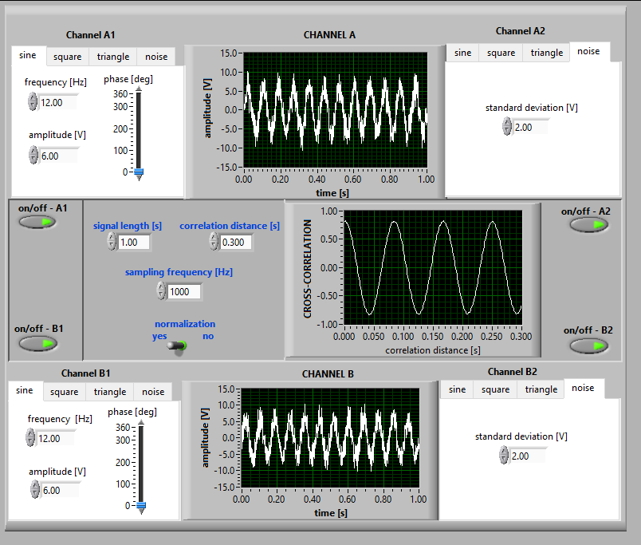
Figure 1 signal lenght [1]
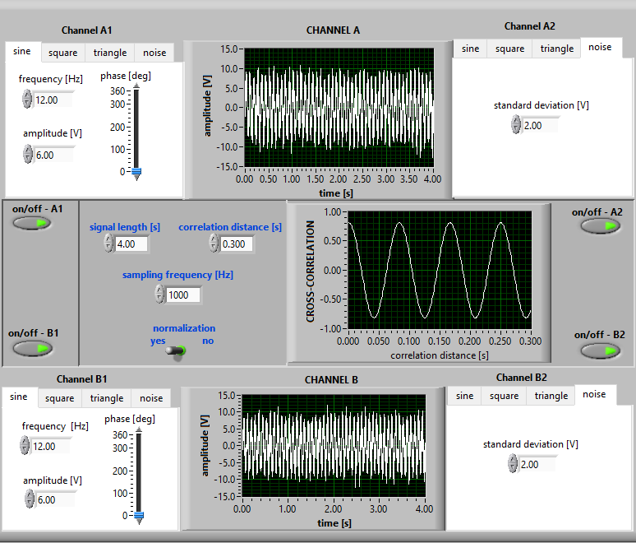
Figure 2 signal lenght [4]
- Analyse the relationships between amplitudes of correlated signals and correlation function for various deterministic signals of the same periods.
This time we have signals with the same frequencies but varying amplitudes and are not compounded. The peak value of the cross correlation function changes according to the variation of the amplitudes. The peak value depends not only on the amplitude but also on the type of signals, but the type of signals must be the same. As can be seen in the figures, the amplitudes are kept constant and only the type of signals is changed, but the peak value of the cross correlation function is changed, which means that there is a different rule for each type of signal.
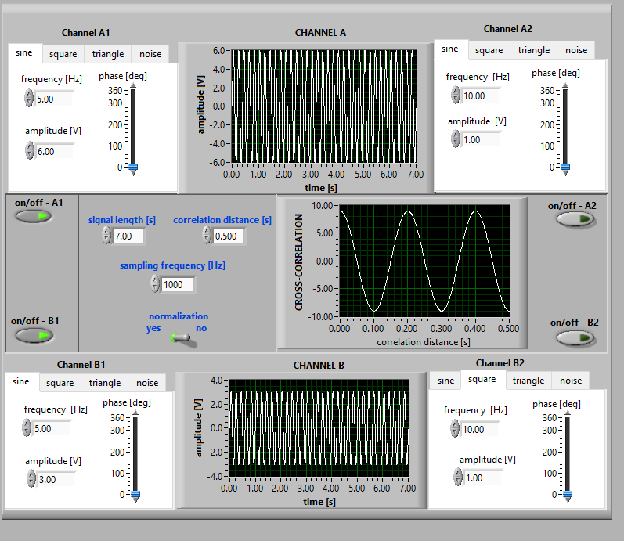
Figure 3
The peak value of the sine(3)-sine(6) signal correlation in Figure 3 is 9, which means that the rule for the sine signal is the amplitude of signal 1 times the amplitude of signal 2. $\frac{Amplitude1*Amplitude2}{2}$
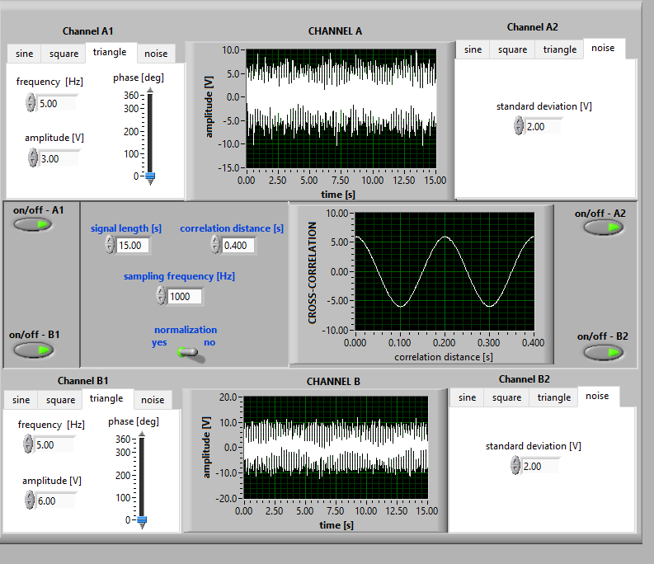
Figure 4
The peak value of the common triangle(3)-triangle(6) signals in Figure 4 is 6, which means that the rule of the sine signal is the amplitude of the 1st signal times the amplitude of the 2nd signal divided by 3. $\frac{Amplitude1 ×Amplitude2}{3}$
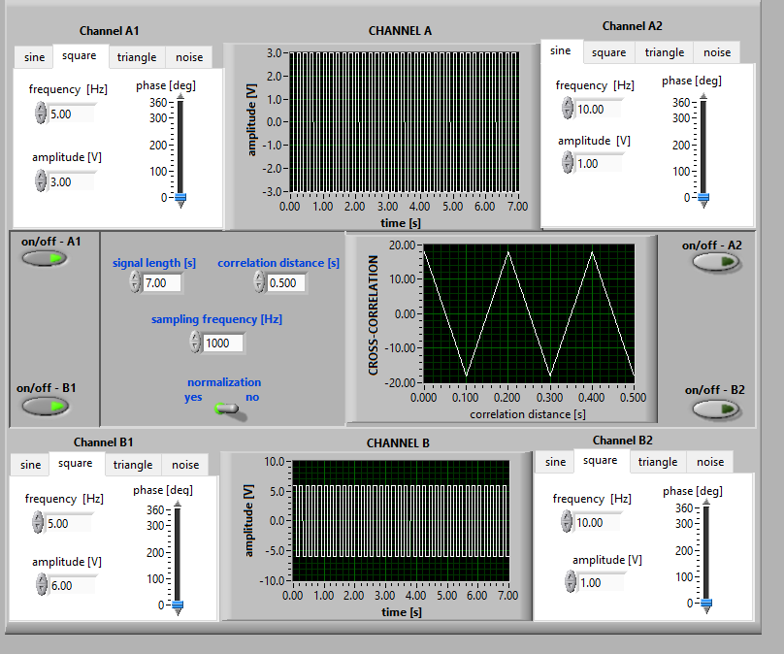
Figure 5
In Figure 5, the peak value of the square-square signals with amplitudes 6 and 3 is 9., which means that the rule of the sine signal is the amplitude of the 1st signal times the amplitude of the 2nd signal divided by 2.$Amp1×Amp2$
The increase in the peak value of the cross correlation function as the amplitude increases means that the signals are linear. Compounding the signals with noise shows that there is no change in the function. If the normalization value in the program is turned on, it is observed that the correlation function is always between 1 and -1.
- Analyse the influence of signals' phase angles on the correlation function distribution for deterministic signals of the same periods.
Phase shows the time difference between two signals. The cross-correlation function measures the similarity between two signals by shifting one, and this shift is called the phase difference. The phase difference indicates how much one signal is ahead or delayed compared to the other and is used to understand delays between signals. As we change the phase angles, the cross correlation function is observed to move and analyzed accordingly.
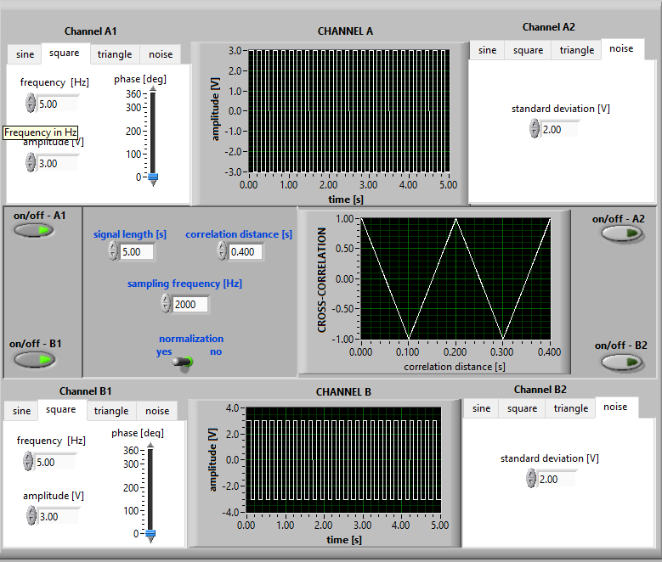
Figure 6

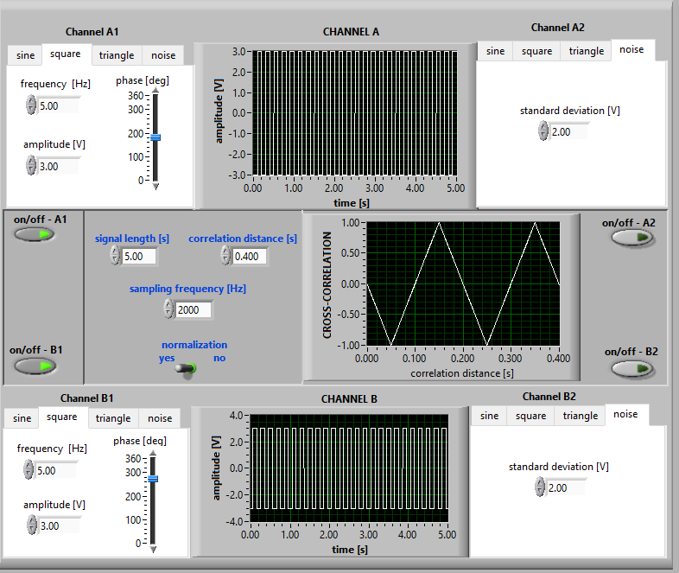
Figure 7
For example, for figure 7 let the phase angle of signal A1 be 270 degrees and the phase angle of signal B1 be 180 degrees. With these changes, the peak of the cross correlation function appears at a correlation distance of 0.05 s instead of 0 s.

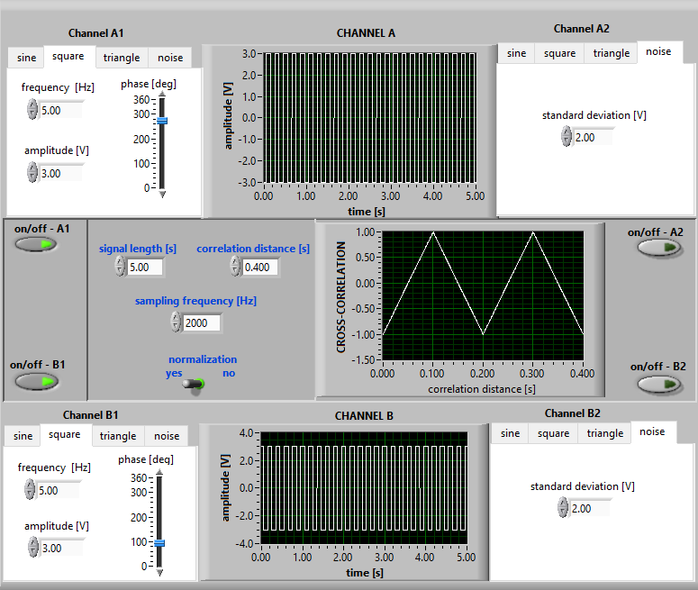
Figure 8
In figure 8, let the phase angle of signal A1 be 270 degrees and the phase angle of signal B1 be 90 degrees. With these changes, the peak of the cross correlation function appears at a correlation distance of 0.1 s instead of 0 s.
- Apply the cross-correlation function to the analysis of the "beat" phenomenon, i.e. combination of 2 sine waves of slightly different frequencies:
In this task, the amplitudes of the 2 signals are kept constant and their frequencies are changed. As shown in Figure 11, the frequency of signal A1 is 25, the frequency of signal B1 is 24 and the signal of the cross correlation function resembles a pair of glasses. In this signal 2 different periods are measured. First, the peaks in the first cycle of the signal, i.e. in the first lens of the glasses mentioned earlier, are counted and divided by 1. The number of these peaks is usually equal to whichever of the given signals has a lower frequency. Since T1 = 1/24 in Figure 11, f1 = 24. The second is the sine wave in two cycles, i.e. in the 2 lenses of the glasses. This is usually the product of the correlation distance and the difference of the frequencies of the 2 signals divided by 1. For Figure 11, if the difference is calculated as 25-24=1 and correlation distance= 2, since T2 = 1/2, f2=2.
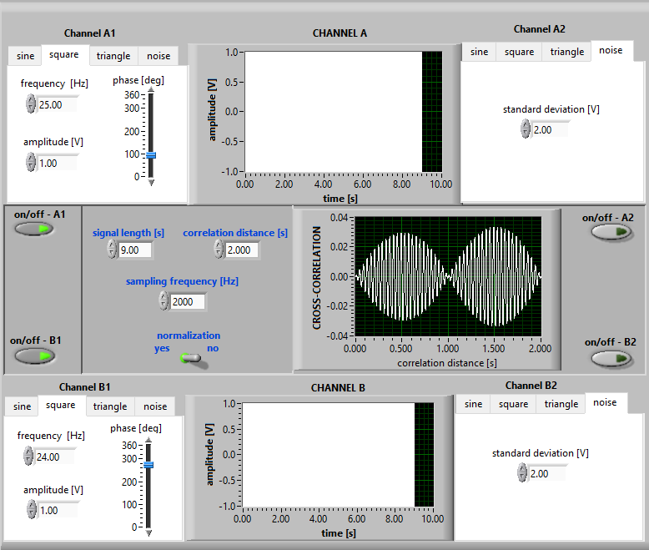
Figure 9
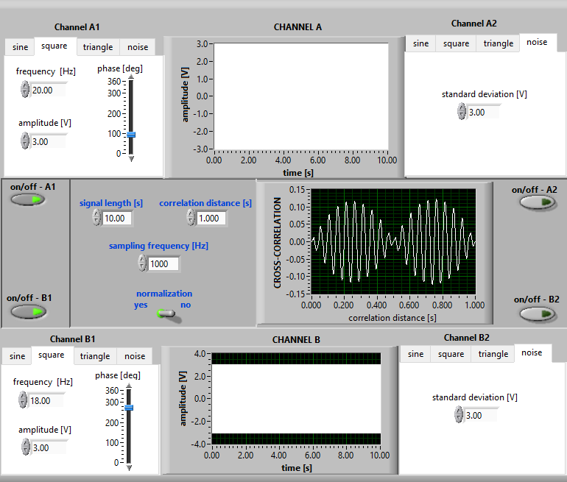
Figure 10
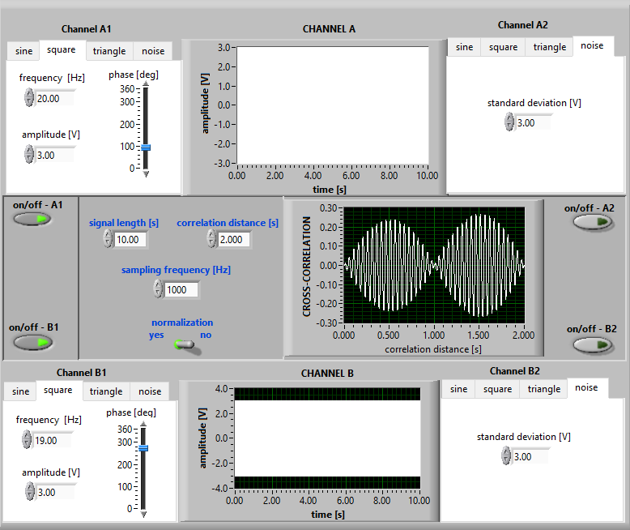
Figure 11
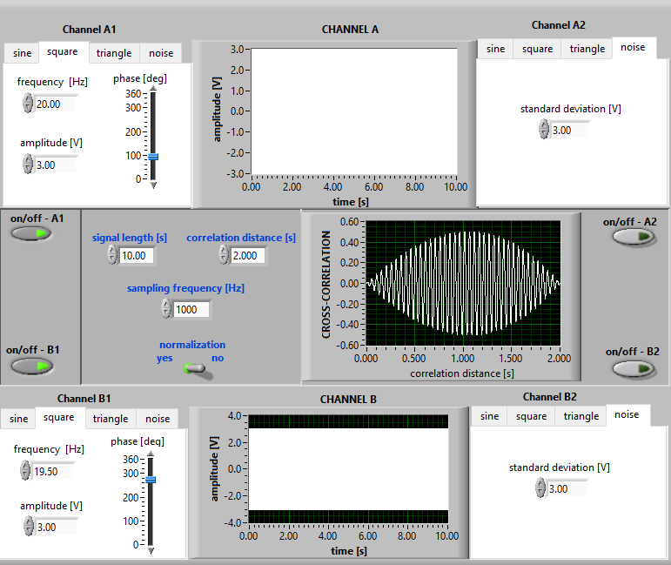
Figure 12
Conclusion
In this study, the cross-covariance function was analyzed for different types of signals. First, the stationarity test showed that the correlation between compound signals with the same period remained stable over time. When examining the relationship between the amplitudes of correlated signals, it was found that the correlation function is sensitive to changes in amplitude, and noise reduces the correlation's clarity. Normalized correlation functions proved to be more useful for comparing signals with different amplitudes.
The impact of phase differences on the correlation function was also explored, showing that phase shifts between signals affect the correlation results. Finally, applying the cross-correlation function to the "beat" phenomenon, where two sine waves with slightly different frequencies combine, helped identify the original frequencies by analyzing the beat frequency.
Overall, this study demonstrated how the cross-covariance function can be used to analyze signal relationships, amplitude effects, phase shifts, and beat phenomena, providing valuable insights into signal analysis.

